**Name:**

**Advanced Programming in C++**

**Lab Exercise 4/18/2024**

Solve the following problems. Submit your fully documented source code as well as sample output and fill in the answer as appropriate.

Use you programming prowess and algorithm development and problem solving skills to solve the following problems

1. Find the smallest positive integer that must be added to 2010 in order to obtain a perfect square (a square of an integer).

Answer: ____________________________________

1. How many digits are in the product of   
   2101 and 599?

Answer: ______________________________________

1. 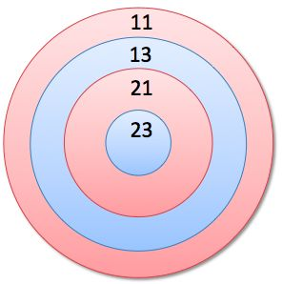On this target, I scored exactly 80.   
   How many shots did I fire?

Answer: ___________________________________

1. What is the largest sum of two integers so that their product is 787?

Answer: __________________________

1. The date July 31, 1370 in MM/DD/YYYY format is a palindrome that may be read the same way in either direction (the same forwards as backwards).   
   07/31/1370  
     
   How many such dates are there from 1352 to 2100?

Answer _________________

1. Two hours ago, I read 78987 miles on my odometer.   
   The number is palindromic, reading the same backwards as forwards.   
     
   How fast was I driving during the last 2 hours if the current number on my odometer is also palindromic?

Answer: ______________________________________